https://veroreves-ek-la.translate.goog/et-renaitre-chaque-jour-de-printemps-p1269174?_x_tr_sch=http&_x_tr_sl=auto&_x_tr_tl=en&_x_tr_hl=da&_x_tr_pto=wapp

And be reborn, each spring day

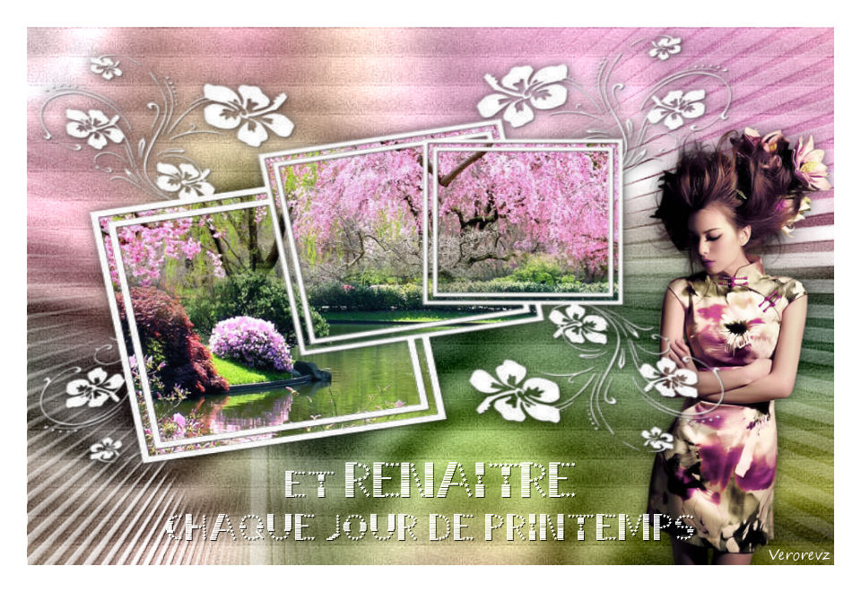

Original tutorial created by Verona on April 17, 2017
A big thank you to the translators who make my tutorials travel around the world
Bea | Stella | Clo | Estela

RELEASE 1  LB Woman Tube  RELEASE 2  Isa's Wife Tube | Filter Unlimited | Narah Mask  Mask of? | on Google Images

STEP 1: the bottom

1.Choose an image of Spring
Edit_Copy

2.Open a new transparent 900 x 600 image
Selection_Select All
Edit_Paste in selection
Deselect
Blur_Adjustments_Gaussian Blur 50

3.Filter Unlimited_Special Effects 1_Plastic Surface

4.Filter Unlimited_Paper Textures_Cardboard Box,Coarse

STEP 2: Narah's mask

1.Add Layer
Fill with white color

2.Layer_New mask layer_From image
Merge group

3.Image_Mirror

4.Layer_Duplicate
Merge with layer below
3D effects_Drop shadow 1_1_60_1 black
Layer Blend Mode = Hard Light

STEP 3: the frame mask

1.Add Layer
Fill with white color

2.Layer_New mask layer_From image
Merge group

3.Add layer
Selection_Load a selection_From disk

4.Copy and paste the landscape into the selection
Deselect

5.Layer_Arrange_Move Down
Activate top layer
Merge with layer below
3D effects_Drop shadow 0_0_60_20 black

6.Edit_Cut
(the layer is copied to the clipboard)

7.Selection tool_Custom selection
Edit_Paste in selection
Deselect

STEP 4: the character

1.Copy and paste the character tube
Resize if necessary
Place well
Add drop shadow 0_0_60_20 black

2.If your tube allows it, you can arrange it under the frames mask

STEP 5: the text

1.Copy and paste the text tube
Layer_Arrange_Place on top of stack

2.Image_Shift Effect

3.Layer Blending Mode = Hard Light

4.Add your signature, merge everything
Image_Add a symmetrical border 30 pixels white color
Export to Jpeg

Thank you for having realized or interpreted
If you wish, you can send me your realization, for exhibition in the gallery
Design and production © veroreves 2017

