https://simpsp-com.translate.goog/leni/tutoriais_leni01/42_colored_life/42_colored_life.htm?_x_tr_sch=http&_x_tr_sl=auto&_x_tr_tl=da&_x_tr_hl=da
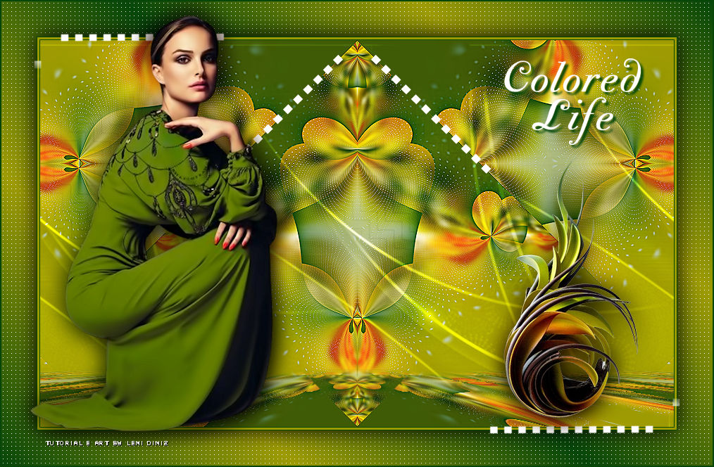

TRANSLATIONS
Thanks to our translators!

Material
Graphic in JPG
1 Tube principal
1 decorative tube
Decor_leni_colored_1
Decor_leni_colored_2
Decor_leni_colored_3
title_leni_colored_life

PLUGINS
Carolaine and Sensibility > CS Dotys
Flaming Pear > Flexify 2
Simple > Blintz
Mura's Meister > Perspective Tiling

CORES
#064709 Foreground (dark color)
#9e9b02 Background (cor clara)

USE:
I provide some graphics,
but it can be done through a landscape, fractal or abstract.
Give it a 20 Radius gaussian blur.
And feel free to choose.
*****
Choose two colors to work with.
#064709 Foreground (dark color)
#9e9b02 Background (cor clara)
Open the material on the psp copy and close the original.

TUTORIAL

01- Open a 900x550 transparent image.
Edit > Copy no 01_graph.
Selections > Select All.
Edit > Paste into Selection.
Selections > Select None.

02- Effects > Plugins > Carolaine and Sensibility > CS-LDots:
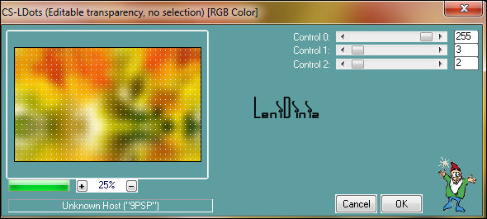

03- Effects > Texture Effects > Weave:
color #064709 Foreground
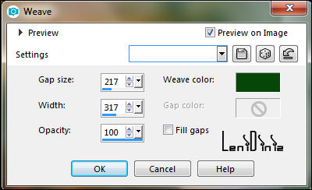

04- Effects > Plugins > Flaming Pear > Flexify 2:

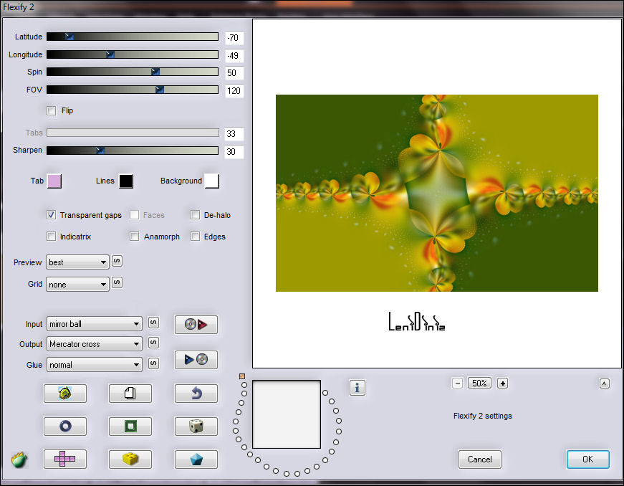
05- Effects > Reflection Effects > Rotating Mirror:
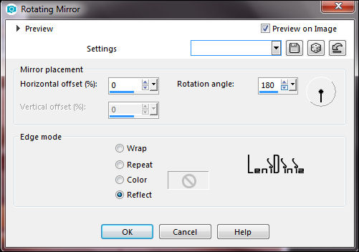

06- Effects > Plugins > Simple > Blintz:
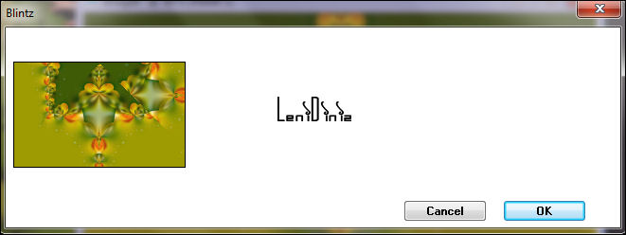

07- Effects > Reflection Effects > Rotating Mirror: Default
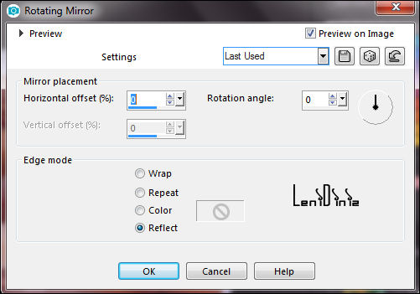

08- Effects > Edge effects > Enhance.
Layers > Duplicate.
Image > Mirror > Mirror Vertical. (FLIP)

09- Effects > Plugins > Mura's Meister > Perspective Tiling:
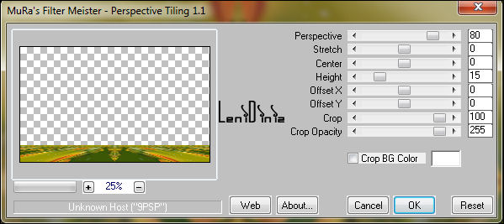

10- Click on the transparent part with the Magic Wand Tool
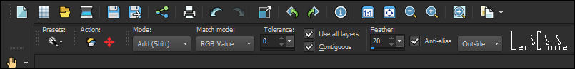
Tolerance 0 > Feather 20

11- Press the Delete key on the keyboard 4 times.
Selections > Select None.

12- Edit > Copy no decor_leni_colored_life-1
Edit > Paste as New Layer.
Ferramenta Pick Tool: Position X: 259 Position Y: 6

13- Edit > Copy no decor_leni_colored_life-2
Edit > Paste as New Layer.

14- Image > Add Borders:
1px - symmetric - color: # foreground cor escura.
3px - symmetric - color: # background cor clara.
1px - symmetric - color: # foreground cor escura.

15- Selections > Select All.
Image > Add Borders > 50px - symmetric qualquer cor.
Selections > Invert.

16- Paint with the Linear gradient formed by the chosen colors:
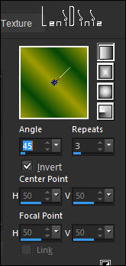

17- Effects > Plugins > Carolaine and Sensibility > CS-LDots:

18- Selections > Invert.
Effects > 3D Effects > Drop Shadow: 0, 0, 100, 45 color #000000
Selections > Select None.

19- Edit > Copy no decor_leni_colored_life-3
Edit > Paste as New Layer.

20- Edit > Copy no tube principal.
Edit > Paste as New Layer.
Image > Resize if needed.
In the tube of the material the resize was 108%
Position where to prefer.
Adjust > Sharpness > Sharpen.
Effects > 3D Effects > Drop Shadow à gosto.

21- Edit > Copy no tube decorativo.
Edit > Paste as New Layer.
Image > Resize if necessary
In the tube of the material the resize was 70%
Position where to prefer.
Adjust > Sharpness > Sharpen.
Effects > 3D Effects > Drop Shadow à gosto.

22- Edit > Copy no title_leni_colored_life
Edit > Paste as New Layer.
Position where you prefer.
Effects > 3D Effects > Drop Shadow à gosto.

23- Image > Add Bordes > 1px - symmetric - color: # foreground cor escura.

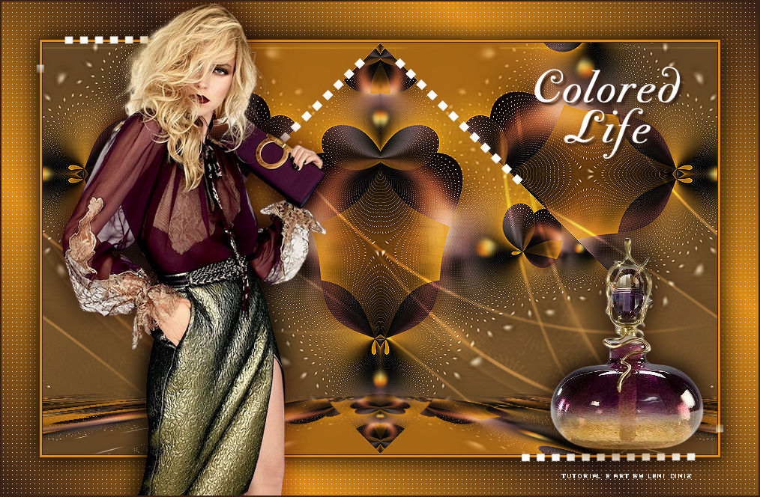
24- Apply your watermark or signature.
File > Export > JPEG Optimizer

Leni Diniz, July 2022.

VERSION:

Credits:
Formatting, Artwork and Tutorial by LeniDiniz
Main and Decorative Tubes: Tubed by LeniDiniz

Feel free to submit your versions.
I will be happy to publish them on our website.

Tutorial created by LeniDiniz in July/2022 - Revised in February/23 for SIM-PSP . It may not be copied, moved, translated or used in learning lists or groups without the prior consent of the author.

